Human Rights  
Negative Case by Drew Magness

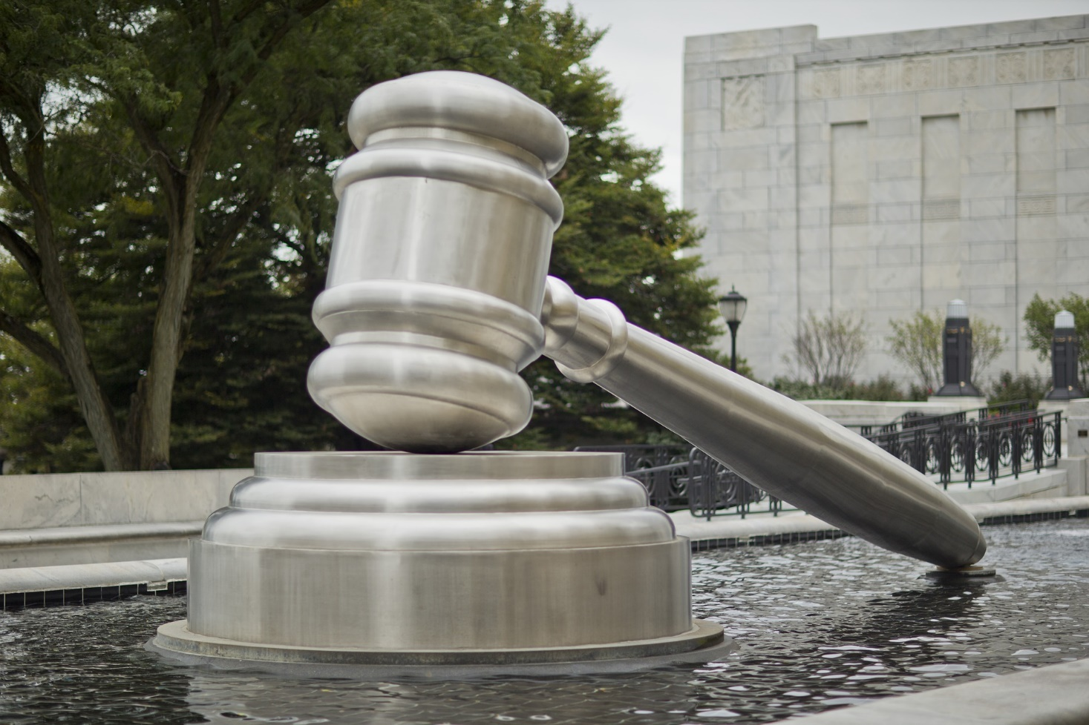

The key to winning as negative this year is to focus on truth-seeking as limitless and pervasive. Affirmatives will try to paint themselves as the good guys, simply trying to hunt down the criminals and do the right thing. You need to paint a picture of terrifying government surveillance, one where government intrusion permeates every aspect of your life. All in the name of “truth.”

The value is important. It’s made to attack utilitarian values like public safety, societal welfare, quality of life, and such. If your opponent runs a value like human dignity or justice, then you can feel free to accept it. All that matters is that the judge isn’t evaluating this based on a theory of effectiveness.

Under the first contention, your opponent is likely to miss the point entirely and argue that truth-seeking has protections in place that prevent limitless surveillance.

Exactly. And where do we put those guardrails? We place them where they allow us to protect privacy. The truth is, if our government valued truth-seeking over individual privacy in the majority of cases, they’d allow the NSA and police officers to monitor everyone, all the time. But they don’t. Because there would be riots in the streets in the name of privacy.

The second contention shows us how our government protects privacy. Attorney-client privilege is an essential hallmark of the legal system. Without it, no one would ever trust their attorney, because there wouldn’t be a legal right preventing someone from coercing the truth out of that attorney.

A key to beating affirmative applications is finding the limits. For example, if they use search warrants, where do we limit truth-seeking in that instance? With individual privacy. A true embrace of the resolution would allow officers of the law to enter into your house without a warrant and discover the truth.

For nearly every example of truth-seeking, its limits are placed to protect your privacy.

Human Rights

Justice Louis D. Brandies famously wrote, “Experience should teach us to be most on our guard to protect liberty when the government's purposes are beneficent.”[1]

Truth-seeking is a noble goal. But when we throw away privacy to collect more facts, we throw away our freedom in order to have a bit more information. That danger is why I stand against the resolution.

# Definition

“Criminal Procedure” is defined by Cornell Law School as “the set of rules governing the series of proceedings through which the government enforces substantive [criminal law](http://law.cornell.edu/wex/criminal_law).”[2] It’s the rules involved with enforcing the law. Now that we understand that, how do we decide today’s resolution?

# Value: Human Rights

We’ll be using the definition authored to us by John Locke when he said that there are three fundamental human rights: Life, liberty, and property.

Here are two reasons to use human rights to measure the resolution…

## Reason to Prefer 1: Moral Priority

Human rights must be the priority of any good government. Think of the countries that we widely consider to have failed their people. North Korea, China, and Venezuela come to mind. We don’t consider them failures because they don’t have booming economies, nice roads, or great education systems. Their foremost problem is their inability to protect the life, liberty, and property of their citizens. When a government throws human rights out the window, they’re throwing their country out the window.

## Reason to Prefer 2: Guards Against Tyranny

Any other framework of governance falls apart when it ignores human rights. If the government cared mostly about public safety, they’d lock everyone in a padded room where no one would ever be hurt. We know that’s evil because it violates liberty. If the government cared mostly about societal welfare, they’d take away all of Jeff Bezos’s money and give it to programs to help the homeless. We know that’s wrong because it violates property rights.

Every other goal of government is limited by human rights. And that’s the way it should be.

To cast your ballot, you simply must ask which side best protects human rights. To answer that question, I have two contentions.

# Contention 1: Truth-Seeking Endangers Human Rights

Truth-seeking is fine when it’s limited by an individual’s right to privacy. When we remove the guardrails that privacy provides, we fall off the cliff and into a blatant destruction of rights. We’ll see this play out in my first application.

## Application 1: Limitless Surveillance

If the government truly cared about finding truth more than your privacy, they’d monitor everything you say or do. The best way to find the truth would be to collect everything you say online and over the phone. This abolition of individual privacy would allow the government to seek all the truth they ever desired.

Would we catch more criminals? Absolutely. If we could see the text messages of drug dealers, listen to the phone calls of burglars, and read the emails of con artists, we’d be able to stop them. But at what cost? The idea of constant monitoring makes us all recoil because we know it would destroy our rights.

The government could now read through all of your personal data. Everything you’ve ever said online, in the hands of a faceless government entity. I don’t have to tell you to be scared of this future. You know that this total ignorance of human rights would destroy your freedom.

This may sound hyperbolic, but it’s the natural conclusion of the resolution. If the government wants to find truth more than it wants to protect your privacy, it will devalue your privacy to obtain that truth. Right now, the fourth amendment prevents the government from doing so. And that’s because of the negative side.

# Contention 2: Individual Privacy Protects Human Rights

Individual privacy doesn’t just allow you to be free of government intrusion into your personal life, it allows our criminal justice system to function. We’ll see how our criminal justice system would fall apart without privacy in the second application.

## Application 2: Attorney-Client Privilege

Imagine if clients couldn’t trust their attorneys. If the government, in the interest of finding truth, required attorneys to tell judges everything their clients told them.

No one would tell their attorney a word. Lips would be sealed. As the Dartmouth office of General Counsel reported,

The privilege is based on several closely-related policy considerations: clients should be encouraged to be completely truthful with their attorneys, so that the attorney's legal advice can be based on all relevant facts; clients will be reluctant to seek an attorney's advice if they fear that their communications will be revealed to others; and by encouraging clients' communications with their attorneys, the privilege promotes voluntary compliance with laws and regulations.[3]

Your information is your property. That’s why we protect your privacy when we allow suspects to make confidential statements to their attorneys. If this weren’t so, the criminal justice system would fall apart.

A world where our concerns for truth know no bounds is one where attorneys reveal all of their knowledge and the government constantly spies on you. We should seek the truth, but only when we don’t have to trample on the foundational rights of American citizens to do so.

Opposing This Case

Of course, your strategy against this case is going to be largely dependent upon your affirmative case. That being said, here are some starting points.

On the value, you can likely accept human rights. You want to discuss how in some cases, we have to devalue certain rights to protect others. For example, we take away your liberty to drive 100mph on the freeway to protect the lives of others. We take away your property through taxation to protect people’s lives and liberty through government actions. Voting affirmative works the same way. We take away the tiniest bit of privacy to protect the human rights of citizens through effective policing. The question becomes, which side BEST protects human rights? And the clear answer is the side that makes us safer. Finding the truth does just that.

Into the contentions, limitless surveillance is a strange idea. Your best bet is to show how limitless surveillance makes it harder to seek the truth. Flooding the government with terabytes of useless information makes it harder to find the helpful stuff. That’s why we require warrants. It’s more efficient. You could also say that surveillance doesn’t fall into the bounds of criminal procedure, which is enforcement of the law. Instead it’s a policy that occurs as a pre-crime procedure.

Attorney-client privilege isn’t a clear application of privacy either. After all, without attorney-client privilege, no one would lose privacy. They’d just choose not to tell their attorneys everything. That’s not a loss of privacy, it’s just people choosing to be more private.

Focus on your case. Be dismissive of these applications and bring the debate round back where it should be, on the affirmative side.

1. Louis D. Brandies, Dissenting Opinion in Olmstead v. US (1928) <https://www.goodreads.com/author/show/1287729.Louis_D_Brandeis>
2. Cornell Law School Legal Information Institute, Last edited in July 2016, “Criminal Procedure” <https://www.law.cornell.edu/wex/criminal_procedure>
3. Dartmouth Office of the General Counsel, No Date Given, “The Attorney-Client Privilege” <http://www.dartmouth.edu/~legal/privilege.html>