The Social Contract  
Affirmative Case by Micah Chapman

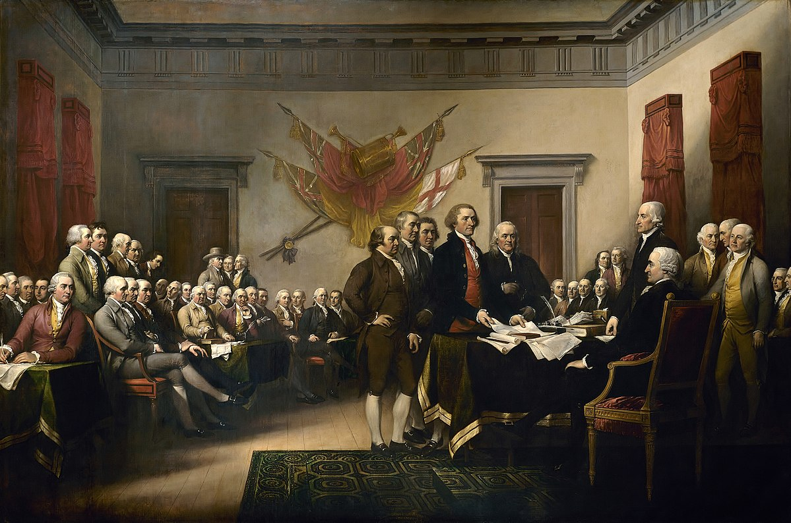

Social contract theory is to Lincoln-Douglas debaters what the Jones Act is to team-policy debaters: There always seems to be some way to incorporate it into any resolution. Although many debaters are tired of the social contract, it is an extremely useful and, if run correctly, simple idea that effectively communicates the relationship between the government and its constituents.

The idea of the social contract is quite simple. It’s an agreement between the people and their government that consists of a trade. This trade means that the people of the country give up some portion of their natural rights, and in return the government protects them by putting laws into place.

The social contract can be applied to things like taxes, voting, property rights, natural defense, and so many other topics. No wonder Lincoln-Douglas debaters use this as their bread and butter; it is the perfect theory. It guides all of the decisions and judgments we make about the society that we live in. To choose a side in any debate that concerns itself with societal behavior without considering the social contract is an incomplete decision.

The problem with the social contract is it often can be misconstrued, badly explained, or just simply confused. If not communicated correctly, judges will not find this argument persuasive. I know this because I have run the social contract many times in various resolutions, and I want you to learn from my numerous mistakes. The key to running the social contract is not necessarily the argument itself, as that tends to stay the same. Instead, the way to run this argument successfully is to make sure you explain it in a way that judges understand, and that appeals to the value system that they have already put in place within their own minds. This is the main reason that I put it alongside the value of justice: the two go hand in hand, but justice exists as a value for persuasive purposes more than anything.

In this resolution specifically, the social contract applies in this way: sometimes, we give up our right to privacy in order for the government to protect the rights to life, liberty, and property for everybody else. This means that given the circumstance when privacy or truth-seeking ought to be chosen, the social contract dictates that, more often than not, truth seeking should be valued higher. The reason is that truth seeking brings about security and justice (make sure to solidify and strengthen that link, as it is the crucial link if your case). If a government, then, has to choose between security and justice or privacy, it has one clear option: it must choose to protect the lives and well-being of its citizens, even if that means making hard decisions and sacrificing some rights.

The main tip to running this case is a rhetorical shift. Make sure that you make the affirmative side sound more like the side of justice, security, and human life, because “truth seeking” can seem weak without a link to innocent human lives. The key to persuasion (and this is true in any Lincoln-Douglas debate resolution) is to make your side seem like the emotional—yet reasonable—choice, and to shift the rhetorical debate to make your opponent’s side seem unimportant.

Have fun.

The Social Contract

Philosopher and author Jean-Jacques Rousseau, in his book *The Social Contract* said,

“The social pact, far from destroying natural equality, substitutes, on the contrary, a moral and lawful equality for whatever physical inequality that nature may have imposed on mankind; so that however unequal in strength and intelligence, men become equal by covenant and by right.”[1]

The government’s first duty is to protect us. However, in return for such protection, sacrifices often need to be made. For this reason, I affirm this resolution, and believe that Criminal procedure should value truth-seeking over individual privacy.

# Definitions:

Criminal Procedure: “The methods of the law that apply to the apprehension, trial, and punishment of the accused.”[2]

Truth Seeking: Any attempt to uncover the truth of alleged criminal activity.

Individual Privacy: “The right that determines the nonintervention of secret surveillance and the protection of an individual’s information.”[3]

# Value: Justice

Justice is defined as: “The result of the fair and proper administration of law.”[4] This definition, although legitimate, does very little on its own to demonstrate *how* to measure today’s resolution, which is why I propose…

## Criterion: The Social Contract

Social Contract Theory is,

“The voluntary agreement among individuals by which…organized society is brought into being and invested with the right to secure mutual protection and welfare or to regulate the relations among its members.”[5]

The relationship between the government and the people of a nation is guided by this theory, stating that sometimes citizens must give up some rights to the government in exchange for the protection the government provides.

# Contention 1: Truth Seeking Ensures Justice

The primary duty of any government is to protect its people. In an ideal world, the government should be able to do so without infringing upon the rights of its citizens. Unfortunately, there are many circumstances that require a government to choose between valuing the rights of their citizens and valuing their protection.

This balance is the very fabric of justice itself. As citizens, we must recognize that in certain circumstances, it is our duty to sacrifice some of our rights in order to function as a society. Imagine if no one ever paid taxes, performed jury duty, or gave back to their society in any way; our country would not work. Although citizens should keep the government in check, they also should give back to the system when it is necessary, even if that means sacrificing some privacy for the greater good.

## Example: Abortion Filming

In 2014, pro-life activists David Daleiden and Sandra Merritt walked into a Planned Parenthood office with hidden cameras recording their conversations. They claim to have gathered evidence that multiple abortion providers were selling tissue from aborted fetuses for profit, which is illegal according to federal law. David and Sandra posted these videos online.

However, instead of using this evidence to shut down these atrocious institutions, the government of California filed felony charges against these two individuals, because filming another person without their consent is illegal in the state of California. The state prosecutors cited “privacy” as a reason for their decision.

And they went further. California soon passed a law preventing the public release of illegally obtained videos such as this one, and the videos have been taken down. Instead of using these and other videos to seek the truth about these detestable actions, privacy was valued, preventing further investigation and stifling justice.[6]

# Contention 2: Preferring Privacy Prevents Justice

According to the fourth amendment to the United States Constitution, all men have a right against unreasonable searches and seizures. This law is often cited as the legal protection of an individual’s privacy. Although privacy is very important, and every American has a right to it, there are circumstances in which privacy becomes less important than the alternative.

Unfortunately, justice often means making uncomfortable and difficult decisions, sacrificing a good thing for something better. In order for our society to function correctly, it is important for us to *value* privacy, but to understand its limitations when put against something more valuable, like truth seeking. Only then can the social contract be fully adhered to, and justice achieved.

## Example: Danielle Van Dam

Seven-year-old Danielle Van Dam was kidnapped in the dead of night by her neighbor, 49-year-old David Westerfield, in February 2002. Westerfield abducted the young girl and murdered her. Her parents were heartbroken over the disappearance, but no significant evidence pointed to any suspect.

A detective on the case, based on a wild hunch, marched up to Westerfield’s door, and lied; telling him that all the houses were being investigated, and she would like to see his. Upon this investigation, she found evidence of Danielle’s abduction, accused Westerfield of the crime, and he was eventually found guilty. Sometime later, Westerfield admitted to the murder. However, if the police officers and Westerfield had been more concerned with privacy, this murderous psychopath may still be walking free today.[7]

This resolution is not an easy decision. Either side you vote for will take away something that is valuable and important for civilized society to function. However, this world is full of difficult decisions. And sometimes we have to recognize that protecting human life, ensuring justice, and letting innocent people go free, is more important than privacy. It’s not an easy decision but voting affirmative saves lives.

Opposing This Case

I’m going to be honest with you, this case takes the persuasive edge, and you will be hard-pressed to find negative examples as emotional and persuasive as these. However, when dissecting this case it is easy to see how behind the fluff of emotional persuasion and *pathos*, the *logos* can fall apart. Make that your goal. Make sure, when arguing against this case, that you do a couple of things:

1. Be the reasonable one. Be the one who has the courage to say, “Yes, abortion is terrible. But do we really want to set a precedent of destroying our privacy and protection of our rights in a half-baked attempt to seek ‘truth’? Think about the ramifications this has on our everyday life, and not on fringe examples.” Be bold but be logical.
2. Truth seeking doesn’t always mean justice. This case makes that assumption, without really understanding that just because you attempt to seek truth does not mean that you always bring about good results.
3. Ends do not justify the means. If I were you, I would say this over and over; drilling it into your judge’s head so that it is the only thing they can remember when they fill out their ballot. Paint the affirmative as an emotional utilitarian, who has seemingly good intentions, but whose mindset, when placed in reality, would be intangibly unjust. Be the gritty realist in this debate.

You can counter with emotional examples if you would like, but do not rely on those to win the round. It doesn’t get much more near and dear to a homeschool parent’s heart than protecting the unborn and little children. Remember, be the one who takes us back to reality. Be the one who’s not afraid to say, “Sure that sounds great, but what does it really mean when we apply it to the real world?” Remember, passion is only 1/3 of persuasion. Use that to your advantage.

Good luck.

1. Good Reads “Jean-Jacques Rousseau.” <https://www.goodreads.com/quotes/52933-the-social-pact-far-from-destroying-natural-equality-substitutes-on>
2. “What is Criminal Procedure? Definition of Criminal Procedure”, Black’s Law Dictionary, 5 Nov. 2011, <https://theladictionary.org/criminal-procedure/>
3. “What Is Privacy? Definition of Privacy”, Black’s Law Dictionary, 2 Mar. 2013, <https://thelawdictionary.org/privacy/>.
4. “Justice Law and Legal Definition”, US Legal Dictionary, 24 Jul. 2009, <https://definitions.uslegal.com/j/justice/>
5. “Social Contract”, Dictionary.com, 23 Aug. 2003, <http://www.dictionary.com/browse/social-contract>
6. “Anti-Abortion Activists Charged in Planned Parenthood Video Case”, The New York Times, 29 Mar. 2017, <https://www.nytimes.com/2017/03/29/us/planned-parenthood-video-charges.html>
7. “How Detective Mo Parga Pinpointed Danielle Van Dam’s Killer”, The San Diego Union-Tribune, 30 Apr. 2017, <http://www.sandiegouniontribune.com/news/columnists/sd-me-dickey-column-0501-story.html>