Probable Cause  
Affirmative Case by Steven Errico

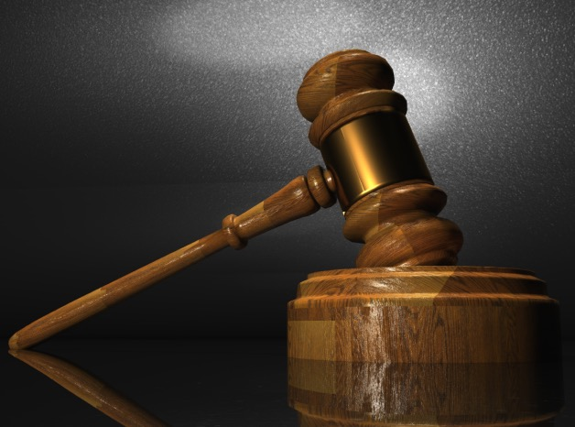

When someone says, “I’m fine,” or “I’m doing well,” I can usually tell when they’re lying. As an intuitive person, I often understand much more of what’s going on than can be seen on the surface. I use the information I have, and I make the most of it and use it to try and figure out the truth.

That’s really the crux of this case. Each and every day, law enforcement across America and around the world protects our **security** (my value) using one incredibly important concept: **probable cause** (my criterion). Probable cause is the prime example of truth-seeking being valued above privacy in the real world, and it demonstrates the truth of the resolution.

In this case, we will look at how warrants work based on probable cause, and we will look at the 2015 mass shooting in San Bernardino and ask, “Should Apple have responded differently when asked to help?” We’ll examine the impacts of valuing each side of the resolution on our security as it relates to probable cause. A look at how the resolution IS regularly upheld in the real world will show us how it has affected our lives today.

My main goal with this case is to demonstrate the importance of keeping our priorities in order. I believe privacy is vitally important, but if we were to value it above truth-seeking, we would be left with a law enforcement unable to act on its suspicions and existing evidence for fear of intruding on privacy.

The most important thing for you to remember when running this case is to keep it simple and keep it concrete. Talk about the real world, and how the ideas in the round impact the lives of the judges each and every day.

Probable Cause

Introduction: Imagine a world where law enforcement cannot do its job. Seriously. Picture a reality in which crimes are not punished and criminals are not brought to justice. It would be chaotic to say the least, and it would look a lot different from our world today. It’s because I believe that seeking and finding the truth is absolutely vital for our safety to be maintained that I stand with the resolution: Criminal procedure should value truth-seeking over individual privacy.

# Resolutional Analysis:

## 1. Definitions

According to the US Legal Dictionary, **Criminal Procedure** is, “the laws and rules governing the mechanisms under which crimes are investigated, prosecuted, adjudicated, and punished.”[1] This essentially covers the whole process of enforcing the law.

Merriam Webster defines **Privacy** as, “freedom from unauthorized intrusion.”[2]

## 2. Valued Above, Not Valued Alone

The affirmative side of the resolution doesn’t say that individual privacy isn’t important; it just means that sometimes we must choose what is **most** important.

# Value: Security

We’re going to operationally define Security as the protection of people, property, and rights.

## Reason to Prefer: Governmental Duty

The very purpose of a government in the first place is to protect its people from threats. If it fails to do that, it fails its primary moral obligation.

# Criterion: Probable Cause

This is really the substance of my case. Not only *should* criminal procedure value truth-seeking above individual privacy, but it actually *does* do this, regularly, through the use of probable cause. In its simplest form, probable cause tells us that we need to have evidence or circumstances that would lead a reasonable person to believe that something illegal will be discovered in order to conduct certain kinds of investigations (i.e. ones that would normally violate someone’s right to privacy). Probable cause is what law enforcement regularly uses to keep us safe.

# Contention One: Truth-Seeking Over Privacy Protects Security

When we look at the landscape of America today and the work that is done in criminal procedure, we see not only the effectiveness but the *necessity* of valuing truth-seeking over privacy.

## Application: Searches, Seizures, and Warrants

The 4th Amendment to the US Constitution says, “The right of the people to be secure in their persons, houses, papers, and effects, against unreasonable searches and seizures, shall not be violated, and no warrants shall issue, but upon probable cause, supported by oath or affirmation, and particularly describing the place to be searched, and the persons or things to be seized.”[3] The 4th Amendment doesn’t mean that police can do whatever they want to find the truth, but rather that if probable cause exists, privacy may be violated in order to protect security.

IMPACT: Pretty much every time that law enforcement wants to apprehend or prosecute potential drug dealers, rapists, murderers, and thieves, probable cause must be employed, and we see from this just how much our focus on truth-seeking through probable cause protects security.

# Contention Two: Privacy Over Truth-Seeking Hinders Security

When privacy gets prioritized over truth-seeking, it comes at the expense of security.

## Application: San Bernardino and Apple

In December of 2015, San Bernardino, California suffered a terrible tragedy. 14 people were shot and killed, and 22 were seriously injured. In the investigation that followed, the very question of the resolution was raised over the iPhone that belonged to one of the perpetrators. The New York Times said in February of 2016,

“The F.B.I. wanted Apple to help ‘unlock’ an iPhone used by one of the two attackers who killed 14 people in San Bernardino, Calif., in December, but Apple was resisting. When the talks collapsed, a federal magistrate judge, at the Justice Department’s request, ordered Apple to bypass security functions on the phone.”

The article goes on to say later that,

“Law enforcement officials who support the F.B.I.’s position said that the impasse with Apple provided an ideal test case to move from an abstract debate over the balance between national security and privacy to a concrete one. The F.B.I. has been unable to get into the phone used by Syed Rizwan Farook, who was killed by the police along with his wife after they attacked Mr. Farook’s co-workers at a holiday gathering. Reynaldo Tariche, an F.B.I. agent on Long Island, said, ‘The worst-case scenario has come true.’ Mr. Tariche, who is president of the agents’ association, added, ‘As more of these devices come to market, this touches all aspects of the cases that we’re working on.’”[4]

IMPACT: While data security is an incredibly important thing to have, Apple’s prioritization of that over seeking the truth about who was behind the attacks hindered the investigation and law enforcement’s ability to prevent another tragedy. The FBI eventually did break into the phone, but not before valuable time was wasted in the investigation. Apple could’ve been a pivotal player in enforcing the law but chose not to be. That was a mistake.

In the end, we understand that it’s necessary to have our priorities in order. While privacy is needed, truth-seeking must always be valued higher in the form of probable cause. If criminal procedure does not value its search for the truth highest, it does not catch criminals, it does not punish crimes, and it does not keep us safe and secure.

Thank you.

Opposing This Case

Your opposition strategy should be pretty straightforward. You could subsume the value with something broader, but don’t bother completely opposing it.

You can also address the fact that probable cause in the real world can work out to be a relatively vague standard. Differing understandings of what probable cause is and what a “reasonable person” is can open it up to be abused by ambitious law enforcement officers.

Here are some key questions around which you can build your opposition strategy:

1. *Should you protect people at the potential expense of their rights without their consent?* – The goal of seeking the truth within criminal procedure is to punish crime and make the world safer, but at what cost are we willing to do so?
2. *Is the truth always found when it is sought?* – Does law enforcement actually make us safer as a direct result of using probable cause in investigations or is the cost to privacy all for naught?
3. *What are the unintended consequences of relentless truth-seeking?* – There have surely been abuses of probable cause in the past: warrantless searches and seizures, warrants that shouldn’t have been issued, etc. Do these consequences outweigh the benefits that we receive?

Of course, in the end it’s always going to come down to how you argue it, but if you can hammer home to the judge the big ideas of the necessity of privacy and the results of seeking the truth, you can beat this case.

1. <https://definitions.uslegal.com/c/criminal-procedure/>
2. <https://www.merriam-webster.com/dictionary/privacy>
3. <https://www.law.cornell.edu/constitution/fourth_amendment>
4. Lichtblau, E., & Benner, K. (2016, February 17). Apple Fights Order to Unlock San Bernardino Gunman's iPhone. Retrieved July 30, 2018, from <https://www.nytimes.com/2016/02/18/technology/apple-timothy-cook-fbi-san-bernardino.html>