Human Rights  
Negative Case by Jascha Ely-Halliwill

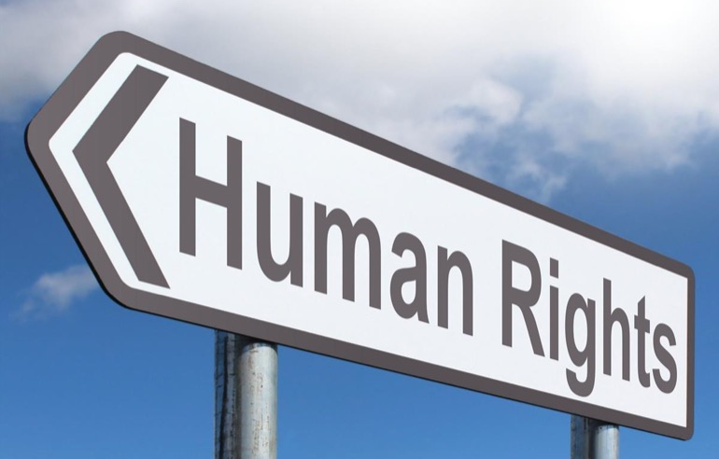

This case has a certain point of view when it comes to criminal procedure. That it is *the important picture*. I’ll be first referencing how to take this case and understand it, and then addressing special strategies that will help when using this case.

Starting with the introduction, I highly recommend practicing and beginning with this immediate connection to the judge. This introduction begins with having the judge(s) imagine something ridiculous, which it is! Having no sense of privacy, much less in criminal procedure is inhumane. Which is the theme of what you will be debating with.

This case takes a logical syllogism in order to achieve its goal. Which is showing that when the resolution is affirmed, it violates human rights. The steps go as this....

1. The framework has a goal, to show that your right to privacy, is a human right. Simple as that. Privacy = Human Right = increased value of Individual Privacy in the debate round.
2. Contentions and Applications show that currently Individual Privacy is being valued above truth-seeking by cause of search/arrest warrants.
3. Current law system values individual privacy before and over truth-seeking = support for value of Human Rights = strength in-round!

If you focus and hone in on the idea that individual privacy is a human right, and that is why it should be valued higher than truth seeking, you should have the round in your hand.

Some tips:

* Let the round be yours. Don’t let the fact and the idea that the privacy of the individual is vital to criminal procedure and the dignity of that individual. Keep the mindset that if a person’s privacy is taken or valued less than other things. You are challenging their very humanity.
* Attend to the impacts in the round. Make sure that in case the round goes awry or gets out of hand by cause of confusion, stick to your impacts, from the definitions to the applications make sure you know why you should win in the round.
* Tell the judge why you win. Now, there’s a fine line between sassy and confidence. Make sure that you stay confident with what you’re saying here. You are trying to sound the most human in-round. Take that advantage.
* Stay simple. In the case your opponent runs the same or similar definitions as you do, just accept them and move on. It’ll make it easier for everyone in the room.

Overall, it took me right around 5:05 to give this case, giving me about 1:55 to respond to my opponent’s case. Aim for the same. Good luck!

Human Rights

“To deny people their human rights, is do challenge their very humanity” - Nelson Mandela.

It is because I agree with the former African-political leader, and that individual privacy is a human right that I negate todays resolution: *In criminal procedure truth-seeking should NOT be valued above individual privacy*.

To start off today’s round, I’d like you to imagine something. Place yourself in a world where there was no such thing as secrets, privacy, or confidential info. Everyone knew what everyone was thinking, everyone owned everything, and no one—absolutely no one—owned anything for themselves.

What’s wrong with that picture? Well, it’s simple. It’s outrageous, ridiculous, and inhumane!

Without further ado, let’s dive into some definitions…

## Definition 1: Criminal Procedure

Is defined by the Business Dictionary as…

“Rules governing how the court will process a criminal case. These rules protect the constitutional rights of suspects and defendants to ensure all stages of (1) investigation, (2) arrest, (3) trial and (4) sentencing are conducted indiscriminately.”[1]

## Definition 2: Truth-Seeking

Is defined by the Citizendium as…

“The attempt to discover deep truths, especially by putting aside simple prejudices and unexamined traditions.”[2]

## Definition 3: Individual Privacy

Is defined by Dictionary.com as...

“Freedom from damaging publicity, public scrutiny, secret surveillance, or unauthorized disclosure of one's personal data or information, as by a government, corporation, or individual.”[3]

Now a Resolutional Analysis…

# RA: Privacy is a Human Right

The Global Internet Liberty Campaign wrote a review on Privacy and Human rights. And they wrote:

“Privacy is a fundamental human right recognized in the UN Declaration of Human Rights, the International Covenant on Civil and Political Rights and in many other international and regional treaties.”[4]

It’s only foundational to consider an individual’s privacy in any case. Not only is it important, but it’s what makes us human, and makes us all so special.

Now, by cause of that, that leads me to my…

# Value: Human Rights

Human rights are the rights that belong to every person individually no matter their precedence. These rights include the right to life, liberty, speech, and what we have already mentioned, privacy. I have one contention:

# Contention: In Criminal Procedure, Individual Privacy upholds human rights.

You can see this through my first example of….

## Application 1: Warrants

Now, before I explain that warrants support my side of the argument, I want to help us understand exactly what a warrant is.

The Business Dictionary mentions that a warrant is:

“Legal authorization issued by a court to... (1) search a place and seize specified items if found there, (2) arrest or detain specified person or persons. Although no hearing is required for issuing a warrant, and no prior notice need be given to the party against whom it operates, the court must be provided with reasonable cause to justify the request for its issuance.”[5]

So why is this important? Warrants are used for truth seeking, that is easily understandable. But that’s the thing. Warrants used by court and by the police are valuing people’s individual privacy before and above they do truth seeking.

Court doesn’t just step on people’s privacy whenever they want, no. because it would violate privacy as a whole if they do. So, warrants are an example of valuing an important human right above an act of truth-seeking.

## Application 2: *Mapp vs Ohio*

The case originated in Cleveland, Ohio, when police officers forced their way into Dollree Mapp's house without a proper search warrant. Police believed that Mapp was harboring a suspected bomber and demanded entry.

No suspect was found, but police discovered a trunk of obscene pictures in Mapp's basement. Mapp was arrested for possessing the pictures and was convicted in an Ohio court. Mapp argued that her Fourth Amendment rights had been violated by the search, and eventually took her appeal to United States Supreme Court.

The U.S. Supreme Court ruled in a 5-3 vote in favor of Mapp. The high court said evidence seized unlawfully, without a search warrant, could not be used in criminal prosecutions in state courts.[6]

There are two impacts I want you to take away from this application.

1. The privacy of Mapp and her constitutional rights were valued above the action of truth seeking by the police.
2. Warrantless actions by court or police lead to unjustified searches.

In conclusion, the impact of truth-seeking may be beneficial in some cases. However, it stretches the limit it can go when it violates the Individual Privacy, a human right of the people.

Opposing This Case

This case is pretty simple, saying that privacy is a human right, thus anything violating privacy is bad and shouldn’t be valued. Well, that’s not necessarily true. What are some cases where someone would volunteer willingly to give their privacy for the sake of something greater? Well, think of anyone in law enforcement or military. They give up certain rights including privacy in order to protect something. Justice and truth. So, this idea is false.

This case has a flaw, and that while it may have the important picture, it doesn’t have the bigger picture. We can’t have truth in criminal procedure without privacy being given up. If truth can’t be attained because of an individual’s privacy, then truth is the only way we can achieve true justice. Or the bigger value.

Finally, this is human rights being used under the criteria of criminal procedure. Not a worldwide application. if this case is being used that way, then it is being argued wrongly.

1. “What Is Criminal Procedure? Definition and Meaning.” BusinessDictionary.com, [www.businessdictionary.com/definition/criminal-procedure.html](http://www.businessdictionary.com/definition/criminal-procedure.html).
2. “Truth-Seeking/Definition.” Napoleon - Encyclopedia Article - Citizendium, <https://en.citizendium.org/wiki/Truth-seeking/Definition>
3. “Privacy.” Dictionary.com, Dictionary.com, [www.dictionary.com/browse/privacy](http://www.dictionary.com/browse/privacy).
4. “Global Internet Liberty Campaign” Privacy and Human Rights - Overview, <https://gilc.org/privacy/survey/intro.html>
5. Is a Warrant? Definition and Meaning.” BusinessDictionary.com, [www.businessdictionary.com/definition/warrant.html](http://www.businessdictionary.com/definition/warrant.html).
6. “Mapp v. Ohio Podcast.” United States Courts, [www.uscourts.gov/about-federal-courts/educational-resources/supreme-court-landmarks/mapp-v-ohio-podcast](http://www.uscourts.gov/about-federal-courts/educational-resources/supreme-court-landmarks/mapp-v-ohio-podcast).