Miranda Rights  
Negative Case by Joel Erickson

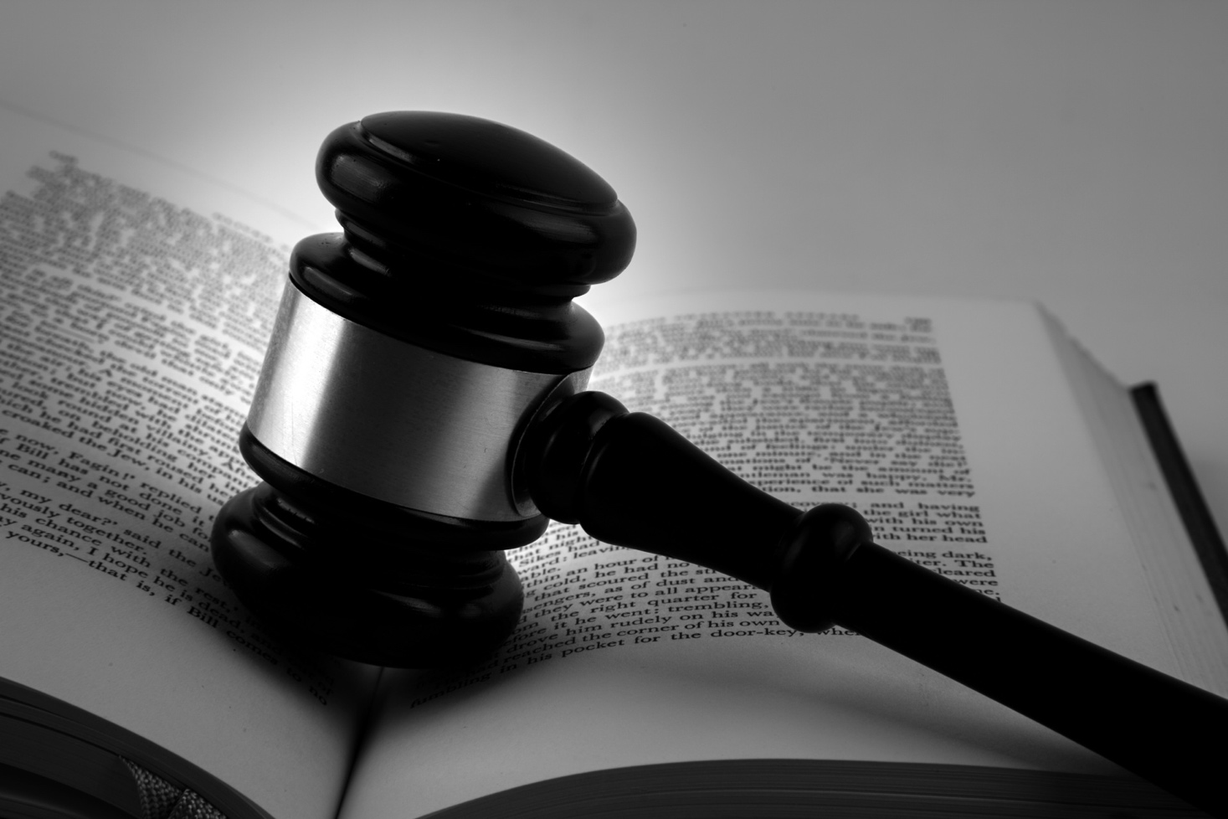

This case leverages rights-oriented impacts without devolving into the circularity of defining privacy as a right. First, either subsume or outweigh your opponent’s value with human rights. If your opponent’s value involves a moral objective, encompass it with your value by demonstrating how its moral significance is ultimately predicated on human rights: Because morality—principles of right and wrong for governing our behavior—is intrinsically a social concern, it depends on a particular conception of humanity to function properly. In other words, moral objectives (like justice, for instance) are reducible to rights. If your opponent’s value is pragmatic, use the reasons to prefer to establish that morality supersedes pragmatism, which automatically impacts to preferring human rights as the value.

Having established the value framework, you should use the first contention to extend the universality of rights to the accused. For rhetorical effectiveness, acknowledge the pervasive reluctance to treat suspected criminals with dignity, but affirm that it remains nonetheless a necessity to act morally and protect innocents. Then the subsequent contentions invariably follow within the framework—privacy checks government intervention (which violates rights) but truth-seeking facilitates it.

Miranda Rights

“You have the right to remain silent. Anything you say may be used against you in a court of law…”[1] We’ve all heard police officers recite this assemblage of statements on CSI or similarly themed television programs. As you probably know, these statements are known as “Miranda rights,” and they represent our criminal justice system’s prioritization of individual privacy over truth-seeking. To protect the rights of the accused, I negate the resolution.

In order to evaluate the comparative worth of truth-seeking and individual privacy, I propose the following standard:

# Value: Human Rights

Thomas Jefferson noted in the Declaration of Independence that “[all people] are endowed by their Creator with certain unalienable Rights, that among these are Life, Liberty and the pursuit of Happiness.”[2] The Constitution, ratified thirteen years later, enumerated myriad extensions of these rights, including freedom of religion, assembly, and speech,[3] the freedom from unwanted intrusion,[4] and freedom against self-incrimination.[5] Both documents specify that human rights do not derive from human institutions, but a supernatural source.

Whichever side better recognizes and protects human rights ought to emerge victorious at the conclusion of the round. You ought to employ human rights as the standard for the following reasons:

## Reason to Prefer 1: Intrinsically Good

Human rights are good in and of themselves. Even if respecting rights accrues us a more beneficial outcome or positive consequences, we still value them because of their intrinsic merit. *[Contrast with your opponent’s value if it is not intrinsically good.]*

## Reason to Prefer 2: Morality Outweighs

Before we ask questions of efficiency or efficacy, we must concern ourselves with morality. What is the *right* thing to do? Because human rights are foundational to the question of ethics, which is an *a priori* issue, we must use it as the standard for the debate round.

# Contention 1: The Accused Have Human Rights

It’s easy to demonize those accused of criminal activity. As we’ve established, however, human rights are universal, entailing that even the accused deserve to be treated with dignity. The United States Constitution affirms this principle:

“In all criminal prosecutions, the accused shall enjoy the right to a speedy and public trial, by an impartial jury of the State and district wherein the crime shall have been committed, which district shall have been previously ascertained by law, and to be informed of the nature and cause of the accusation; to be confronted with the witnesses against him; to have compulsory process for obtaining witnesses in his favor, and to have the Assistance of Counsel for his defense.”[6]

Jacob Hornberger, attorney and former professor at the University of Dallas, notes the devastating impact of ignoring the rights of the accused:

“Is the Sixth Amendment relevant today? You bet it is, especially given the Pentagon’s use of military tribunals in another country, Cuba, for people accused of terrorism. Ever since their arrest, people accused of terrorism at Guantanamo Bay have been indefinitely detained and denied the right to counsel, due process of law, habeas corpus, trial by jury, and even the right to know exactly what they are being charged with. Most of the proceedings are as secret as they were in the Star Chamber and in Hitler’s People’s Court.”[7]

Justice demands that we only punish the guilty. Respecting the rights of the accused guarantees them immunity from unjust convictions if they are innocent.

# Contention 2: Individual Privacy Upholds the Accused’s Rights

Individual privacy safeguards the sacrosanct rights of the accused through preventing government interference. A primary example of this principle is…

## Application: Miranda Rights

According to *Justia*, a legal database, “The name of the Miranda doctrine comes from the U.S. Supreme Court’s decision in [*Miranda v. Arizona*](https://supreme.justia.com/cases/federal/us/384/436/case.html), 384 U.S. 436 (1966). The case involved a defendant who confessed to a crime after several hours of interrogation by police. At no time did the officers advise him of his right against self-incrimination or his right to consult with a lawyer. The court admitted the defendant’s written confession, over his objection, at trial, and he was convicted. The Supreme Court ruled that the coercive nature of the police’s custodial interrogation required them to advise the defendant of his Fifth and Sixth Amendment rights. It further ruled that an interrogation must cease if a suspect asserts the right to silence or to an attorney.” Through providing a barrier of individual privacy, Miranda rights ensure that the government will not trample individual rights in the pursuit of truth.

# Contention 3: Prioritizing Truth-Seeking Undermines the Accused’s Rights

Without individual privacy as a check on government truth-seeking, human rights are jeopardized. As Emily Bazelon puts it in an article for *Slate*,

“The next time you read about an abusive interrogation, or a wrongful conviction that resulted from a false confession, think about why we have Miranda in the first place. It’s to stop law enforcement authorities from committing abuses. Because when they can make their own rules, sometime, somewhere, they inevitably will.”[8]

Coupled with the human propensity to denigrate criminals, government overreach is inevitable. Coercive interrogation techniques can result in false confessions, which impede justice and desecrate the human rights of innocents. According to a study published in *The Economist*, a quarter of those exonerated via DNA evidence confessed to crimes they did not commit.[9] Privacy reduces these risks through safeguards like Miranda rights.

In the spirit of cherishing human rights, the eminent English jurist William Blackstone wrote that “better ten guilty persons escape than that one innocent suffer.”[10] Prioritizing truth-seeking might prosecute more guilty people but empirically inflicts grievous violations on the rights of innocents. Prioritizing privacy, on the other hand, safeguards the rights of the accused innocents.

Opposing This Case

One option involves replacing this case’s underlying deontology with moral pragmatism:

* Paradigm #1: Deontology -- The government must avoid immoral actions at all cost, regardless of the consequences.
* Paradigm #2: Moral Pragmatism -- The government must avoid immoral consequences at all cost, regardless of the actions.

The first paradigm asks, “Is the government violating human rights?” The second paradigm asks, “Do the governments actions cause more rights violations?” Invert Blackstone’s ratio and contend that the paramount value is protecting the human rights of the greatest number of people—ten guilty individuals released into society would likely perpetrate more crime, thereby wreaking havoc on more human rights. Thus, harming one innocent would not be as problematic because the net rights violated would be less overall.

Alternatively, you could attack the contention arguments. Michael Cicchini, JD, argues that the Miranda system is dysfunctional in an article published in the SMU Law Review.[11] Furthermore, in the 1984 decision *New York v. Quarles*, the Supreme Court accommodated an exception to *Miranda v. Arizona* in situations of public safety, situations in which truth-seeking might supersede privacy. Moreover, you could argue that false conviction statistics are insignificant and anomalous.

1. “What Are Your Miranda Rights?” <http://www.mirandawarning.org/whatareyourmirandarights.html>, 2018.
2. Declaration of Independence, Independence Hall Association, <http://www.ushistory.org/declaration/document/>, 2018.
3. First Amendment, US Constitution, <http://constitutionus.com>.
4. Fourth Amendment, US Constitution, <http://constitutionus.com>.
5. Fifth Amendment, US Constitution, <http://constitutionus.com>.
6. Sixth Amendment, US Constitution, <http://constitutionus.com>.
7. Jacob Hornberger, “The Bill of Rights: The Rights of the Accused,” The Future of Freedom Foundation, <https://www.fff.org/explore-freedom/article/bill-rights-rights-accused/>, 1 February 2005.
8. Emily Bazelon, “Why Should I Care that No One’s Reading Dzhokhar Tsarnaev His Miranda Rights?” *Slate*, <https://slate.com/news-and-politics/2013/04/dzhokhar-tsarnaev-and-miranda-rights-the-public-safety-exception-and-terrorism-cases.html>, 19 April 2013.
9. “Silence Is Golden,” *The Economist*, <https://www.economist.com/science-and-technology/2011/08/13/silence-is-golden>, 13 August 2011.
10. Alexander Volokh, “*n* Guilty Men,” *University of Pennsylvania Law Review* 173 (1997), <http://www2.law.ucla.edu/volokh/guilty.htm>.
11. Michael Cicchini, “The New Miranda Warning,” *SMU Law Review* 65, no. 4 (2012), <https://scholar.smu.edu/cgi/viewcontent.cgi?article=1209&context=smulr>.