Balancing Identity  
Resolution Philosophies by Alisa Stringer

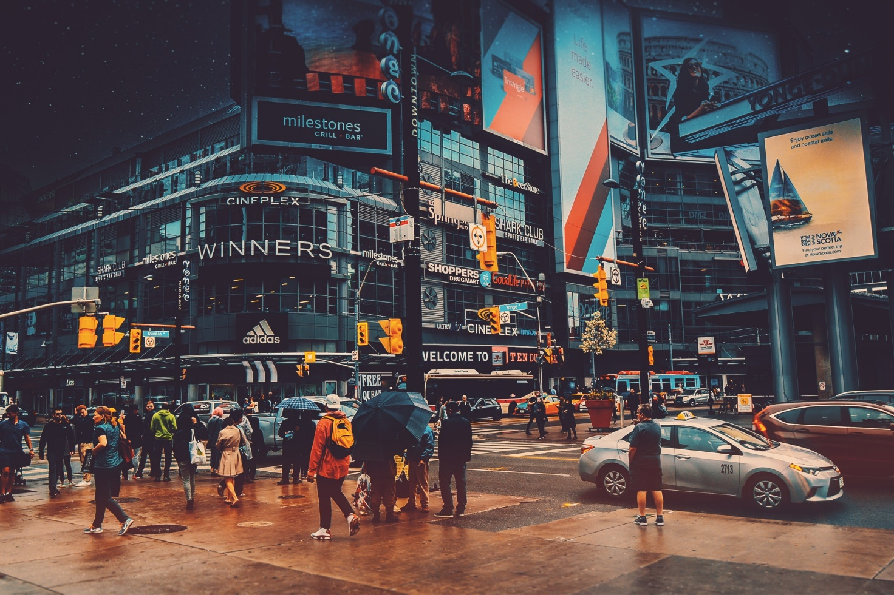

Culture is an incredibly flexible concept. It can refer to common values, habits, or traditions, but it can also be a group of people. When culture refers to a group of people, it could be a group of more than a million individuals, or less than fifty. For example, there exists an American culture, but within the American culture there exists a Texan culture. In the Texan culture, there is a big difference between the Houston culture and the Austin culture. And so we could go on, dividing into smaller and smaller subgroups.

Given the complexity of the first term in this resolution, it is already obvious that debaters need to be rock solid in their understanding of this debate. But our discussion becomes even more intricate when we consider how individuals move between cultures. Any person will routinely identify with many different cultures depending on their physical situation, personal beliefs, and even their moods. Given this constant shift of personal identity, discussions involving culture can often become incorporeal, where mangled philosophies are thrown around on a whim. The purpose of this article is to prepare you to use the terms of this resolution and the philosophies behind this topic effectively and responsibly.

# What is Assimilation Anyway?

The terms “assimilation” and “multiculturalism” are inextricably interconnected. In the forty-five minute competitive debates, it will be all too easy to confuse the terms. It is important to avoid ground-shifting in this resolution, in order to have a clear and fulfilling debate. ‘Assimilation’ involves ethnic groups giving up their culture and becoming one with the majority group. ‘Multiculturalism’ involves minority groups living within a majority culture while still keeping their distinct culture. Neither of these are connected to the popular ‘melting pot’ theory, where groups merge on equal footing to create a new culture. Before any philosophy can enter the picture, the terms of the debate must be completely understood.

# Cultural Differences Affect Lives

Assimilation itself is the subject of many fascinating studies. Humans typically react best to familiarity. When something, or someone, appears foreign, subconscious – and in unfortunate cases conscious – avoidance is a common response. Even if a person is attempting to assimilate, there are many challenges that they will face through the process.

## Importance of Names

Professor Ran Abramitzky published an article for Stanford on research concerning the effect that names have on the success of immigrants. He found that,

“Having an American-sounding name was a badge of assimilation that conferred genuine economic and social benefits. We looked at census records of more than a million children of immigrants from 1920, when they lived with their childhood families, through 1940, when they were adults. Children with less-foreign-sounding names completed more years of schooling, earned more, and were less likely to be unemployed than their counterparts whose names sounded more foreign. In addition, they were less likely to marry someone born abroad or with a foreign-sounding name. These patterns held even among brothers within the same family. The data suggest that, while a foreign-sounding name reinforced a sense of ethnic identity, it may have exposed individuals to discrimination at school or on the job.”[1]

There are many possible causes for these results, including philosophical reasons such as patriotism and nationalism, as well as practical reasons such as fear of the unknown. Whatever the case, Abramitzky’s work highlights one of the many challenges that immigrants face. Should they use a traditional name, which may help them feel close to their culture, or should they adapt their name for success in the dominant culture? Theoretical discussions on assimilation and multiculturalism have very real impacts on immigrant populations.

# Assimilation = Power Dynamics

With the introduction to the resolution complete, we can look more specifically at the two sides of the resolution. Assimilation is primarily about the power relationship between groups of people. Groups who are viewed as ‘more sophisticated,’ both historically and internationally, have very few concerns about assimilation. Groups whose culture has been denigrated are far more likely to be encouraged or even forced to assimilate.

## Double Standards

In a 2017 Times article, novelist and essayist Laila Lalami explored the philosophy of power associated with assimilation, while providing examples from her own personal life. She wrote that,

“It should be clear by now that assimilation is primarily about power. In Morocco, where I was born, I never heard members of Parliament express outrage that French immigrants — or ‘‘expats,’’ as they might call themselves — eat pork, drink wine or have extramarital sex, in plain contradiction of local norms. If they do adopt the country’s customs or speak its language, they aren’t said to have ‘‘assimilated’’ but to have ‘‘gone native.’’ In France, by contrast, politicians regularly lament that people descended from North African immigrants choose halal food options for school lunches or want to attend classes in head scarves. One result is a daily experience of rejection, which only makes assimilation more difficult.”[2]

Her analysis shows how today’s minority groups are expected to give up their culture if they want to succeed. But majority groups have gone further to ‘educate’ and ‘civilize’ people whose cultures they did not understand.

## Cultural Decimation through Childhood Education

One of the worst cases of power dynamics playing out in forced assimilation is the case of the American Indian boarding schools. The national park service worked with the Odawa tribe to describe the conditions and results of the boarding schools.

“The first mission school at Little Traverse was built in 1829 and was a collaboration of the local Odawa and missionaries. During the next two decades, Catholic schools would be built at Cross Village, Middle Village and Burt Lake. In 1887 Indian education became dictated under federal standards which included the boarding school system. Odawa children, along with all Indian children across the United States, would be subject to some of the most intense assimilation in American history. Odawa children at the boarding schools would not be permitted to speak their native language or to participate in ceremonies or cultural activities. Severe punishment was administered when rules were broken. Prolonged stays at the school were common, sometimes years on end. The long absence from family and community, in conjunction with the strict rules of the school, resulted in a loss of language, culture and history for the tribe. The Holy Childhood boarding school in Harbor Springs opened in 1889 and ceased operation in 1983. In the words of the founder of the American boarding schools Richard Pratt, “that all the Indian there is in the race should be dead. Kill the Indian in him and save the man.” What Pratt and others did not count on were the powerful bonds that would form at boarding schools and the fact that Indian culture would manage to survive.”[3]

With the rather dark side of forced assimilation on full display, it may seem easiest to write assimilation off as a complete failure. However, there are still positive sides to assimilation. The problem with cases such as the American Indian boarding schools is that the assimilation is forced on minority groups without regard for what they want. Forced assimilation implies that certain cultures are inherently more valuable than others. That is not true of all assimilation.

Assimilation can also be used to remove power imbalances. In some cases, it is even an inevitable process of time.

## Immigration as an Inevitability

Whenever people live in close proximity, they will naturally begin to take on the habits and traits of the people they are near. The Harvard Gazette produced an article on the study of immigrant assimilation.

“The study looked at immigrants and native-born Americans of similar backgrounds. For example, it compared immigrants with high educational attainment to native-born of high educational attainment, and native-born from poor backgrounds to immigrants from poor backgrounds. Overall, immigrants are more likely to be poor, 18.4 percent compared with 13.8 percent for native-born Americans. This is the case even though a greater proportion of immigrants work. The poverty rate declines over time, approximating that of the native-born in the second generation, and then falling to 11.5 percent in the third generation. Young immigrant men with low levels of education commit fewer crimes than their native-born counterparts, the report said, and foreign-born men ages 18 to 39 are jailed at one-fourth the rate of native-born men. The impact of this is felt in cities where concentrations of new immigrants align with lower crime rates, Waters said. Immigrants are in much better health than native-born Americans, with lower rates of obesity, smoking, and cancer, which all went up as they assimilated. Also, Waters said, immigrants are likelier to be raised in two-parent families than native-born Americans of similar background. “Integration is a neutral thing. They become like native-born Americans, better off or worse off,” Waters said.”[4]

# Multiculturalism: Drawing Boxes

Multiculturalism can easily be seen as the more respectful of the two ideologies of the resolution. After all, multiculturalists believe that people should be allowed to keep their cultures because no culture is perfect but all are unique and valuable. The potential problem with multiculturalism is that it requires a definition of ‘one culture.’

## Culture Has Always Been Shared

If you were asked to describe your culture, what would you say? It is typical for people to engage in some common cultural practices. For example, many Americans celebrate Christmas, Thanksgiving, and the Fourth of July. But it is important to notice that celebrating these holidays does not make a person American. There are plenty of Americans who do not observe these days. Some non-religious American families see little point to Christmas; many Americans see Thanksgiving as a problematic celebration of the subjugation of indigenous people. Some Americans celebrate the day of the dead, despite its origins in Mexico.

The point is, culture is osmotic and flexible. Culture has always been shared and adapted, and multiculturalism can too easily define groups out of connection with one another. As the Stanford Encyclopedia of Philosophy explains,

“Some critics contend that theories of multiculturalism are premised on an essentialist view of culture. Cultures are not distinct, self-contained wholes; they have long interacted and influenced one another through war, imperialism, trade, and migration. People in many parts of the world live within cultures that are already cosmopolitan, characterized by cultural hybridity. As Jeremy Waldron argues, “We live in a world formed by technology and trade; by economic, religious, and political imperialism and their offspring; by mass migration and the dispersion of cultural influences. In this context, to immerse oneself in the traditional practices of, say, an aboriginal culture might be a fascinating anthropological experiment, but it involves an artificial dislocation from what actually is going on in the world” (1995, 100). To aim at preserving or protecting a culture runs the risk of privileging one allegedly pure version of that culture, thereby crippling its ability to adapt to changes in circumstances (Waldron 1995, 110; see also Appiah 2005, Benhabib 2002, Scheffler 2007).”[5]

## Beauty in Diversity

On the other hand, multiculturalism stands as a model for allowing many communities to exist together without requiring minority groups to give up their ethnic and cultural identities. Multiculturalism has the potential to improve all cultures while still preserving the unique identities that are too often undervalued in today’s fast-paced globalized society. As Dr. Sev Ozdowski wrote on the success of Australian multiculturalism,

“The aim of contemporary multiculturalism in Australia is for all to participate on equal terms, to access opportunities and focus on nation building without need for ethnic ghettos or separateness from the community at large. Over the years, Multiculturalism in Australia maintained 2 key values: tolerance of racial, cultural and religious difference, underpinned by the acceptance of Australian values such as equality of the sexes and the rule of law. Migrants also participate fully in the Australian economy and to deliver the so-called ‘productive diversity’ dividend because of their links to the globalised economy. Under multiculturalism, migrants are expected to join the broader Australian society and its political and cultural institutions at their own pace. This policy aims at integration with ‘human face’ and dignity. It allows for preservation and transfer to the next generation of minority cultural and linguistic heritage that did not conflict with the Australian core values. It is, however, expected that newcomers upon arrival in Australia will give up their foreign loyalties and in particular involvement with the country of origin conflicts and ethnic or religious hatreds. In other words, contemporary Australian multiculturalism must be seen as a compact or two way street between the Australian society and newcomers that requires both give and take.”[6]

1. Abramitzky, Ran. "What History Tells Us about Assimilation of Immigrants." Stanford Institute for Economic Policy Research, Stanford University, Apr. 2017, siepr.stanford.edu/research/publications/immigrants-assimilate. Accessed 9 July 2019.
2. Lalami, Laila. "What Does It Take to Assimilate in America?" New York Times, 1 Aug. 2017, [www.nytimes.com/2017/08/01/magazine/what-does-it-take-to-assimilate-in-america.html](http://www.nytimes.com/2017/08/01/magazine/what-does-it-take-to-assimilate-in-america.html). Accessed 9 July 2019.
3. Hemenway, Eric, and Odawa. "Indian Children Forced to Assimilate at White Boarding Schools." National Park Service, 18 Apr. 2019, www.nps.gov/articles/boarding-schools.htm. Accessed 11 July 2019.
4. Powell, Alvin. "Measuring Assimilation." Harvard Gazette, 21 Sept. 2015, news.harvard.edu/gazette/story/2015/09/measuring-assimilation/. Accessed 19 July 2019.
5. "Multiculturalism." Stanford Encyclopedia of Philosophy, Stanford U, 24 Sept. 2010, plato.stanford.edu/entries/multiculturalism/#UniIdeEqu. Accessed 23 July 2019.
6. Ozdowski, Sev. "Australian Multiculturalism: The Roots of Its Success." Western Sydney University, www.westernsydney.edu.au/equity_diversity/equity_and_diversity/tools_and_resources/reportsandpubs/australian_multiculturalism_the_roots_of_its_success#multiculturalism. Accessed 23 July 2019.