Safety  
Affirmative Case by Jascha Ely-Halliwill

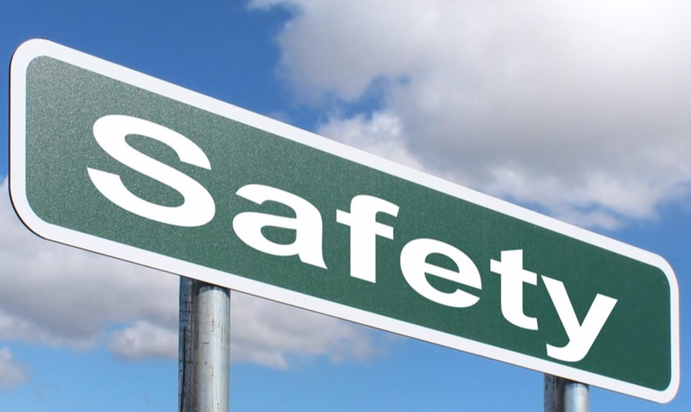

This case’s strong suit is simplicity. And there’s a couple things I’d suggest.

First, understand that all the applications are based in the United States. NOT because America is the best example, but rather because the U.S. is an easy-to-understand application. Any judge will comprehend the Civil War and US citizen impacts.

Second, this case is just off of one claim. That assimilation leads to a safer culture, and that a safe culture is of the utmost importance. That’s your battle when you’re handling this case.

Try not to overcomplicate the argument by saying multiculturalism doesn’t lead to a safe environment, but rather say that it leads to a less safe environment compared to assimilation.

Safety

Often times, when we look at societies, we can bicker over what beliefs we think are more important. Doing this leads to a lot of clash that oftentimes ends fruitless. Because of this, I believe that the way we can decide is through which application culture keeps the people safe.

This is why I stand resolved: Culture ought to value assimilation over multiculturalism.

# Resolutional Analysis 1: Needs Enforcement

Assimilation and multiculturalism aren’t just open-ended ideals. They are movements in time and progression that assume that some government or entity of authority said, “Let’s assimilate this culture” or “let’s have a diverse culture.” So when we discuss these two things, we must understand that we cannot vote for either side without conceding the fact that there will be authorities running the show.

# Definitions

## Culture

Merriam-Webster. *Merriam-Webster Dictionary*. Accessed September 30, 2019. <https://www.merriam-webster.com/dictionary/culture>

A : the customary beliefs, social forms, and material traits of a racial, religious, or social group

## Assimilation

Encyclopedia Britannica. *Encyclopedia Britannica*. Accessed September 30, 2019. <https://www.britannica.com/topic/assimilation-society>

Assimilation, in anthropology and sociology, the process whereby individuals or groups of differing ethnic heritage are absorbed into the dominant culture of a society. The process of assimilating involves taking on the traits of the dominant culture to such a degree that the assimilating group becomes socially indistinguishable from other members of the society. As such, assimilation is the most extreme form of acculturation. Although assimilation may be compelled through force or undertaken voluntarily, it is rare for a minority group to replace its previous cultural practices completely; religion, food preferences, proxemics (e.g., the physical distance between people in a given social situation), and aesthetics are among the characteristics that tend to be most resistant to change. Assimilation does not denote “racial” or biological fusion, though such fusion may occur.

## Multiculturalism

The International Federation of Library Associations and Institutions. *IFLA*. Accessed September 30, 2019. <https://www.ifla.org/publications/defining-multiculturalism>

"Multiculturalism" is the co-existence of diverse cultures, where culture includes racial, religious, or cultural groups and is manifested in customary behaviours, cultural assumptions and values, patterns of thinking, and communicative styles.

Value

## Safety

Dictionary.com. *Dictionary.com*. Accessed September 30, 2019. <https://www.dictionary.com/browse/security>

1.freedom from danger, risk, etc.

## Reason to Prefer: Meaningless culture without safety

Yes, we can talk about how important diversity is. But, in all honesty, an unsafe culture is a meaningless culture to live in. We must ensure that the people in this territory are able to have that freedom to express their beliefs, but also have that guarantee that they won’t be killed for expressing their traditions.

# Contention 1: Assimilation helps safety

When a culture is not only similar in status, but also similar in the way they view the protection of their territory, it means a safer environment. It’s only logical, to say that a nation or culture that has the majority of people in it that love where they live. It means less people hating the culture and hurting it.

## Application 1: US citizenship

To become a United States citizen, it’s not that simple. You have to not just have a green card or a visa, but you have to read, write, and have a complete understanding of US history and literature. But why? Well, because this country also values its culture. We value our language, our history, and our traditional standards.

It's only logical to say that a patriotic citizen will make a culture and community safer. And America is a wonderful example of that.

The impact is. That we have a safer community by having people that actually care or have love for this culture. This culture we live in, values assimilation over diversity, because we value safety and effectiveness.

## Application 2: Post-American Civil War

The American Civil war was a travesty, something we will address later in a different contention. But we also see that the Civil War ended in assimilation. Right after President Abraham Lincoln made and signed the Emancipation Proclamation. Which not only resulted in resolve, but practically forced the south into a predicament where either they assimilate to the new moral standard, or things will worsen. And what do we see now? Now no longer is America split into two different nations trying to kill each other. Thus we are safer.

# Contention 2: Multiculturalism doesn’t uphold security

Now, looking at the opposite end of the spectrum, if a culture has a community that hates and dislikes its traditions, it results in aggression, harm, and separation of its people. But how do we know that is true? ….

## Application 3: The American Civil War

The civil war is an example where the US had two cultures existing at the same time. And it failed. We allowed both the north and the south to fight each other because they both disagreed on how the countries culture should go. Slaves or no slaves. State rights to own people vs the Federal government saying ‘no’

But the very fact that these two cultures existed, brought in spite, then bringing the death. The impact is, that when you have multiple cultures, much less two, who disagree on a vital issue. It can mean horrific implications for the people of that culture, hurting its security. Over 620,000 people died in the US civil war. All because Multiculturalism brought that threat upon its people.

(*Approx 5:45 speaking time*)